**Out-of-plane path of the Stone–Wales transformation in graphene**

<https://www.sciencedirect.com/science/article/pii/S0375960115003394#fg0020>

Supercell size: 160 atoms

Method: nonorthogonal tight-binding model

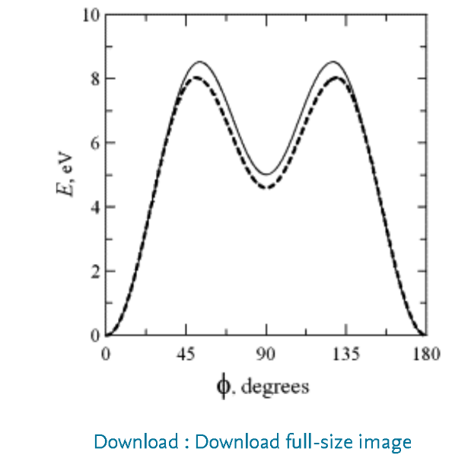For FSWT

 ϕm=52.5°

Uf=E(ϕ=ϕm)−E(ϕ=0)=8.52eV

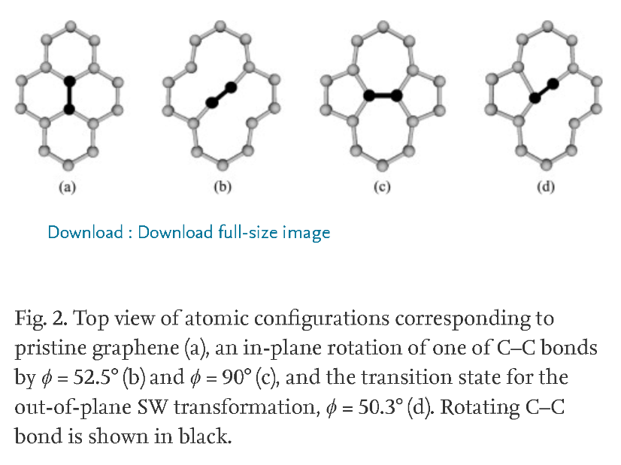Fig. 1. Energy E of a 160-atom graphene supercell versus the angle ϕ of C–C bond rotation. Solid curve relates to in-plane bond rotation resulting in a flat SW defect (the rotated atoms do not displace in the vertical direction). Dashed curve corresponds to the non-planar SW transformation bringing about the formation of a buckled sinelike SW defect (both atoms of the rotated bond move out of plane, and the angle ϕ quantifies the rotation of the C–C bond projection on a graphene plane).

For out of plane SWT: energy peaks at ϕm=50.3°, energy barriers U to formation and annealing of the sinelike SW defect are, respectively, Uf=8.03eV and Ua=3.43eV, each being by ΔU=0.49eV lower than for the in-plane path.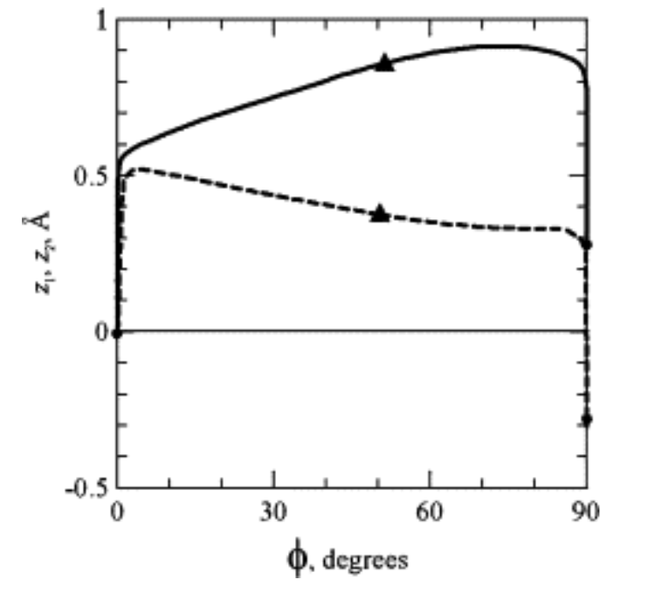

**Lubrication of Stone–Wales transformations in graphene by hydrogen and hydroxyl functional groups**

<https://iopscience-iop-org.ezproxy.lib.calpoly.edu/article/10.1088/0957-4484/24/43/435707/pdf>

Energy Barriers: EFTSC = 10.2 eV EUTSC = 9.3 eV

Discusses rearrangement of other atoms in the FSWT:

A1–B1 distance is substantially larger than in the pristine lattice.

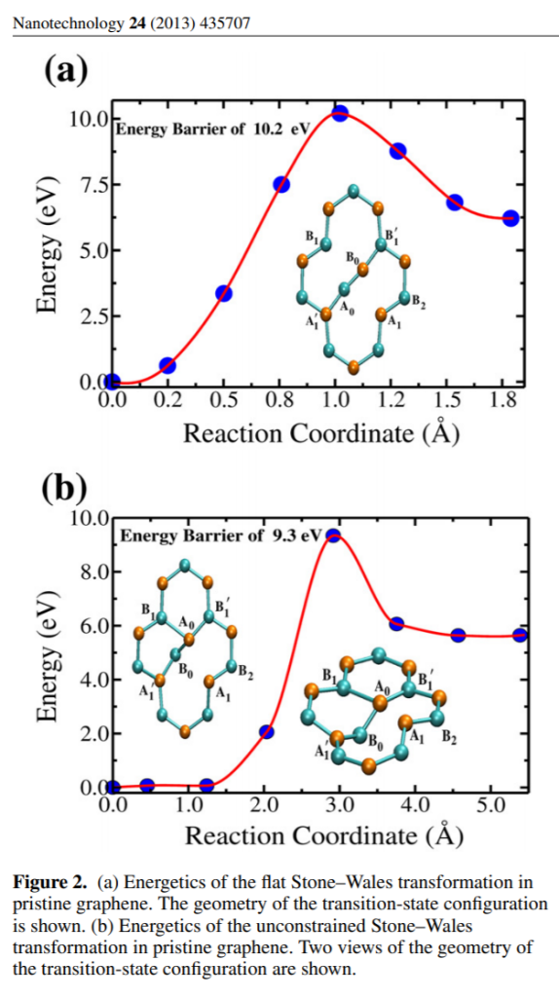The A0–B0 bond length is 1.29 A and the A ˚ 0–B0 1 and A0 1 –B0 bonds are shortened to 1.36 A, from 1.42 ˚ A in pristine graphene.

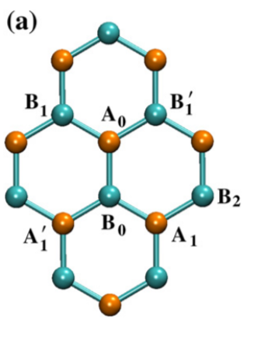Discussion of transition state in USWT:

In the UTSC, while the C atoms at the A0 and B’1 sites remain in the graphene plane, that on the B0 site shifts ‘down’ by −0.95 A, being accompanied by the A’1 and B1 atoms, which shift off-plane by −0.52 A and ˚ −0.15 A, respectively. ˚ The larger upwards shift are experienced by the A1 site (0.47 A) and one of its neighbors (0.40 ˚ A) in the perimeter ˚ of the SW defect.

**Stone-Wales defects in graphene and other planar sp2-bonded materials**

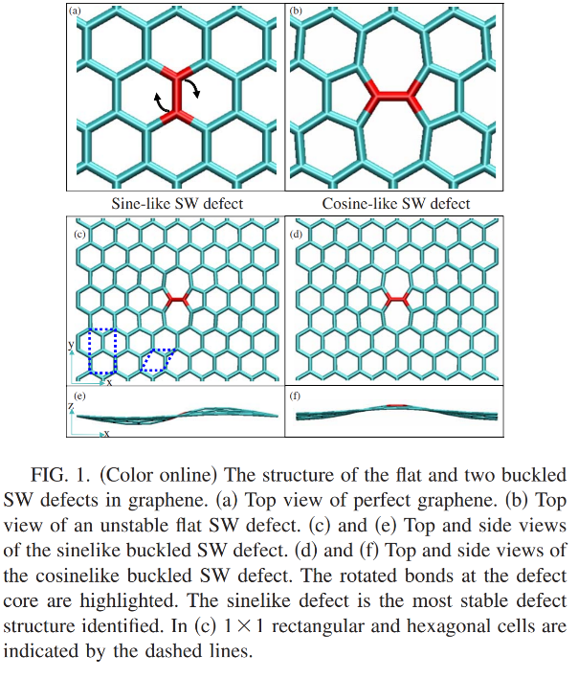<https://journals-aps-org.ezproxy.lib.calpoly.edu/prb/pdf/10.1103/PhysRevB.80.033407>

Not much discussion of transition state in this one, besides:

This sinelike structure is a true minimum with no imaginary frequencies, whereas the cosinelike structure is a transition state with one imaginary frequency.

Nudge Based elastic band method: <https://aip-scitation-org.ezproxy.lib.calpoly.edu/doi/pdf/10.1063/1.1329672>

<https://journals.aps.org/prb/abstract/10.1103/PhysRevB.80.033407>